**Posture Checker Report**

**Dawson College - Electrical Engineering Technology Department**

**Introduction to Internet of Things - PBL Project**

**Team Members:**

* Kaeo Kloss – (2444653)
* Constanza Avila Ramirez (2442005)

**Date of Submission:** May 13th, 2025

**Project Description**

The *Posture Checker* is an IoT-based solution that detects wether or not your posture is correct. Serving as a reminder to users how to properly sit on a chair. It helps you check your head and back position by using an ultrasonic sensor. All kind of users can use this product thanks to the wide range of outputs used, including light and sound alarms to alert any signs of a bad posture.

**What does this solve?**

Bad posture can lead to long-term health issues, such as back pain and spinal discomfort. This device provides real-time feedback to correct posture before it leads to chronic problems.

**Final Assembly Diagram**

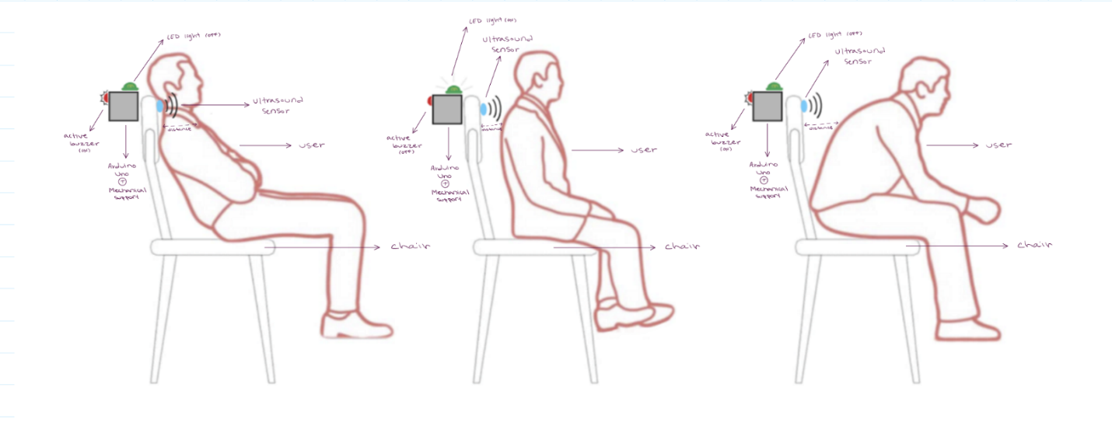

**Circuit Diagram**

**Inputs:**

* Ultrasonic Distance Sensor (HC-SR04): used as a sensory input. It emits ultrasonic sound waves and measures the time it takes for the echos to return. The input to the system from this sensor is the measured distance.
* Push Button: serves as a manual control input. This could be used to activate or deactivate the system, change modes, or trigger a specific action.

**Outputs:**

* LED (Warning Indicator): visual output. When the system determines the met conditions, it will activate or deactivate the LED to emit light, providing a visual warning or indication.
* Buzzer (Alert Sound): auditory output. The system can activate the buzzer to produce a sound when conditions are met, providing an audible alert.

**3. Code Documentation**

**Main Structure**

The code is structured to:

1. Continuously measure the distance between the user and the sensor.
2. Check if the measured distance indicates bad posture.
3. Trigger visual (LED) and auditory (buzzer) alerts if bad posture is detected.
4. Allow the user to silence the alarm using a button.

**Function Descriptions:**

* checkDistance(): Measures the distance in centimeters using the HC-SR04 sensor.
* triggerAlert(bool alert): Activates or deactivates the LED and buzzer based on posture status.
* handleButton(bool badPosture): Monitors the button state to silence the alarm if bad posture is detected.

**4. Ethics, Privacy, or Security Disclaimer**

This project does not collect or store personal data. Its sole purpose is to provide real-time feedback to the user regarding posture correction. The system is closed-loop and only interacts locally with the user, ensuring privacy and security.

**5. References**

1. Elegoo Starter Kit Documentation
2. NewPing Library Documentation
3. Arduino Reference Guide
4. Course notes
5. Chat gpt

**6. GitHub Repository**

[Editing PBL-/PBL - posture checker.docx at main · St4anza99/PBL-](https://github.com/St4anza99/PBL-)

Prepared by: Kaeo Kloss and Constanza Avila Ramirez  
Dawson College, 2025